**Training time calculation for different datasets**

1. **10k**

Total time taken to train all the models = **15 minutes**

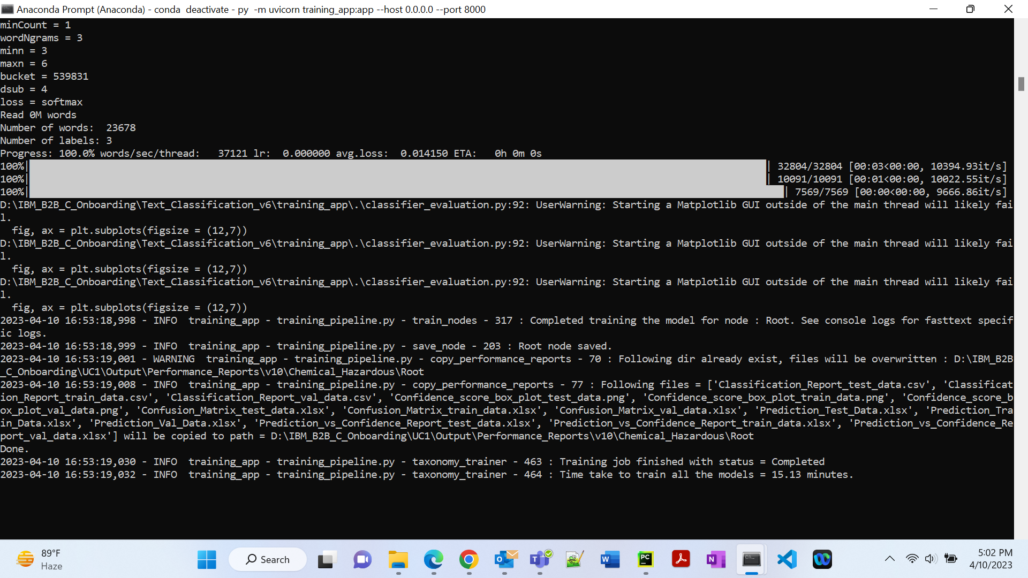

Flat classification, Total time taken to train all the models = **14 minutes**

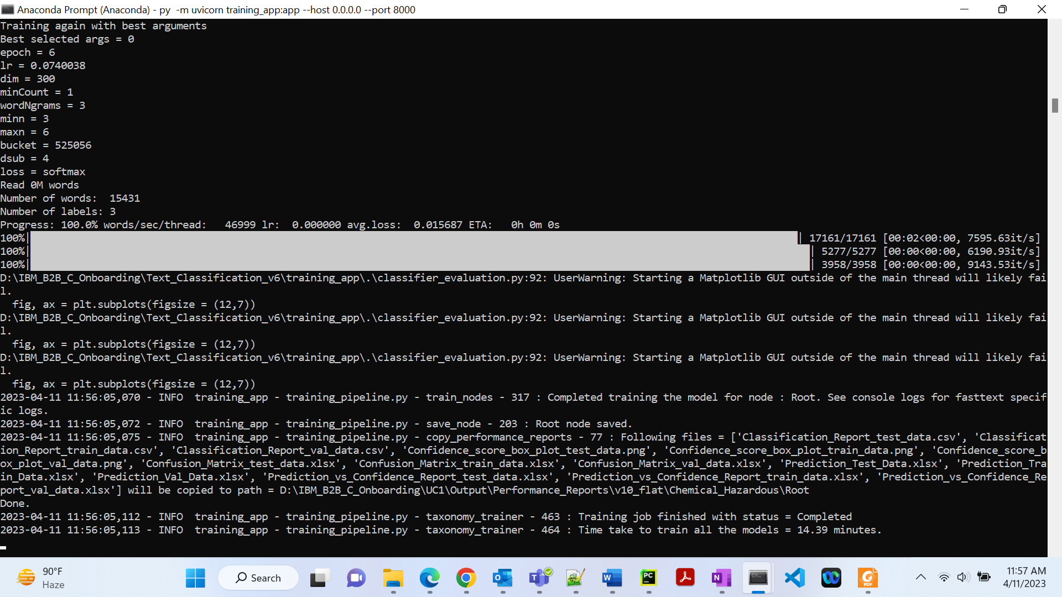

1. **25K**

Total time taken to train all the models = **16** **minutes**

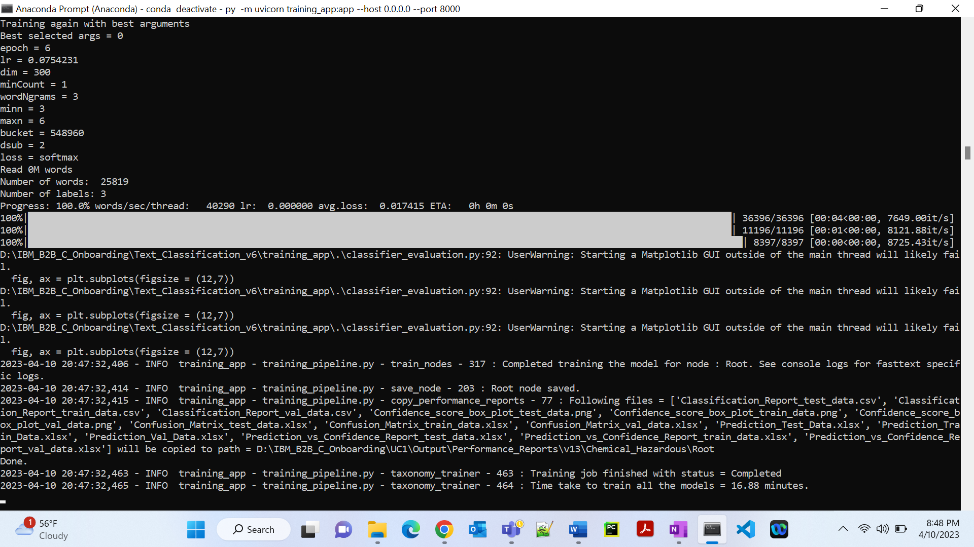

Flat classification, Total time taken to train all the models = **16 minutes**

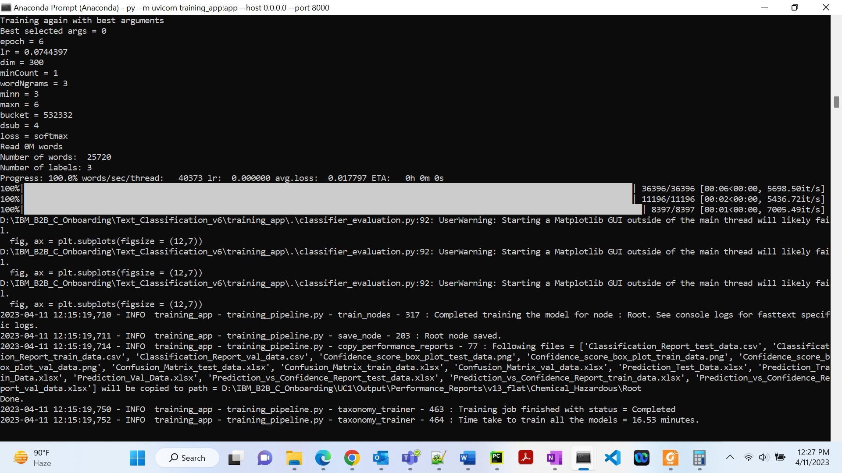

1. **60K**

Total time taken to train all the models = **18 minutes**

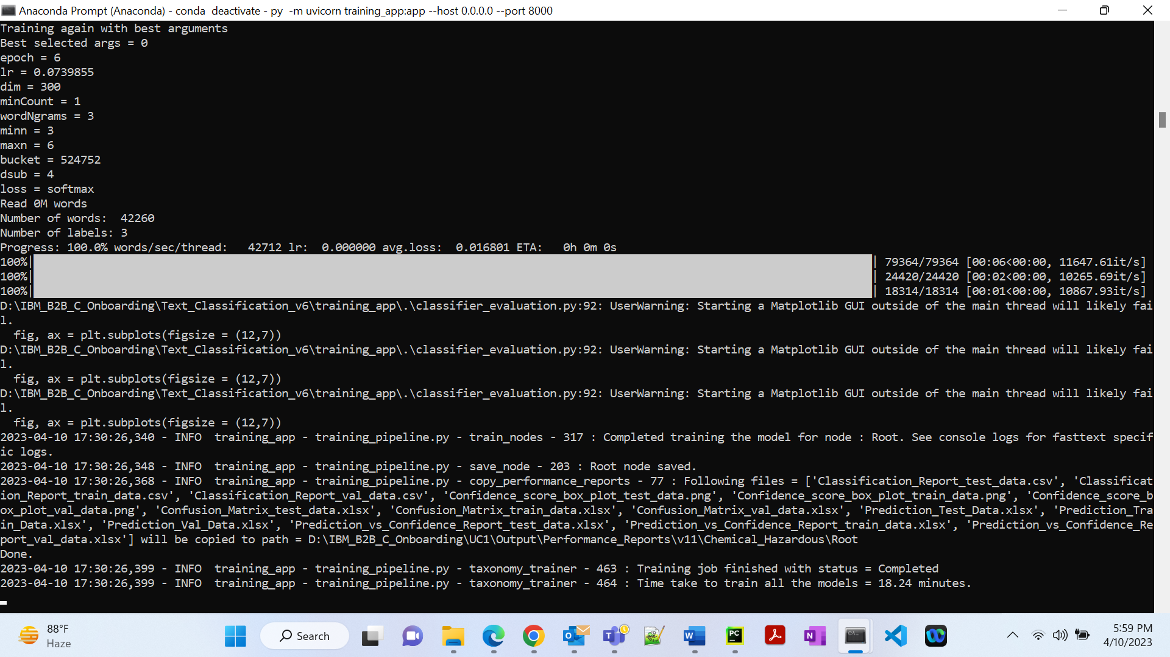

Flat classification, Total time taken to train all the models = **20 minutes**

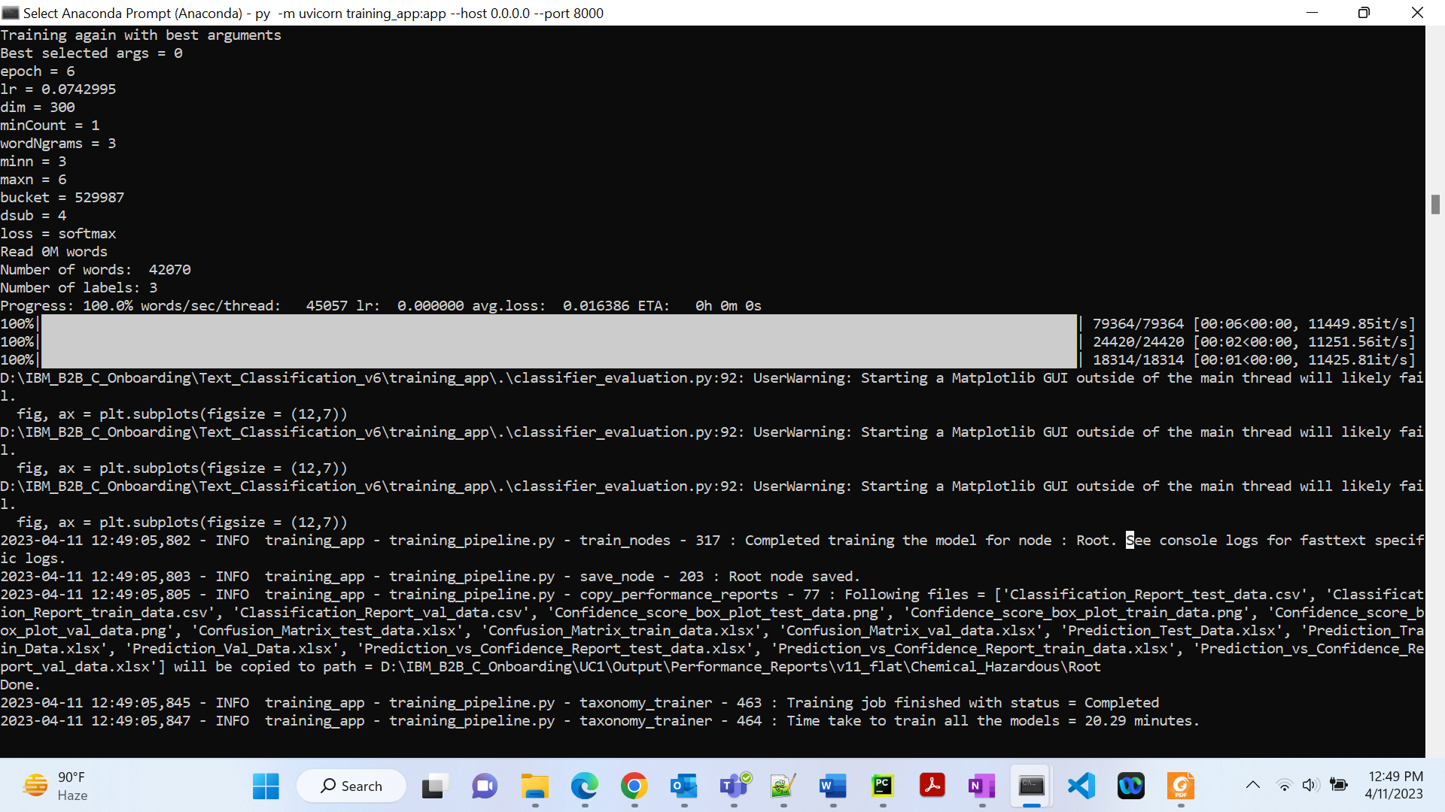

1. **90K**

Total time taken to train all the models = **20 minutes**

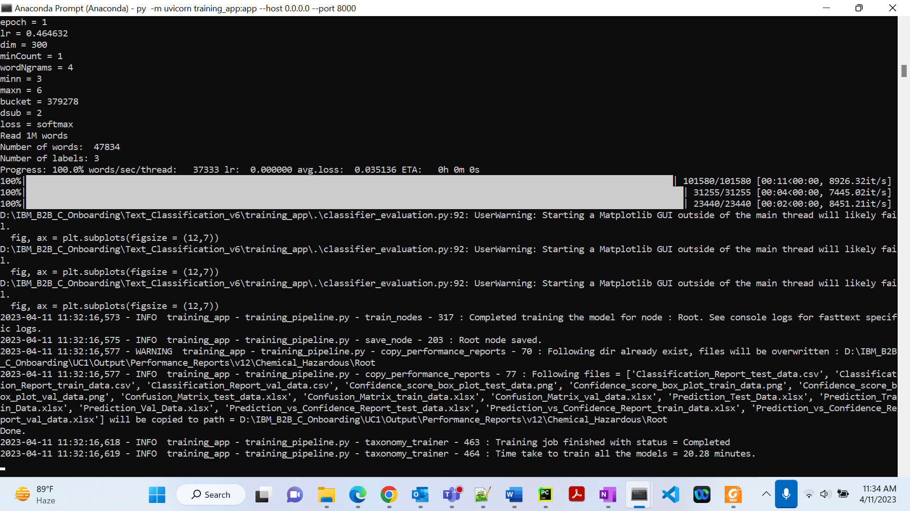

Flat classification, Total time taken to train all the models = **19 minutes**

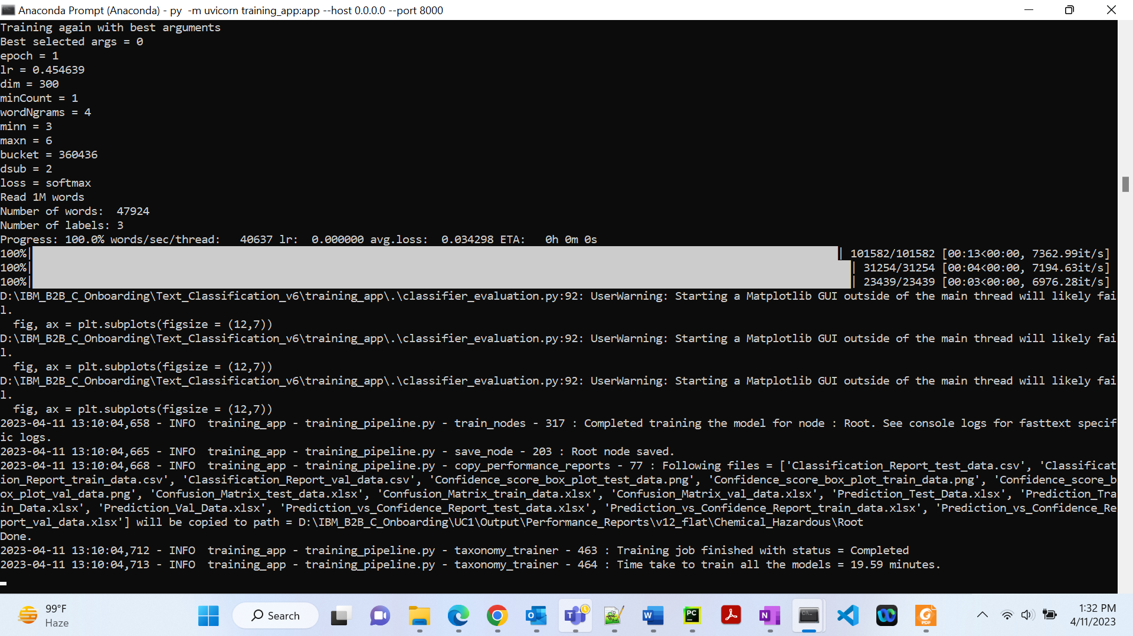

1. **1L**

Total time taken to train all the models = **20 minutes**

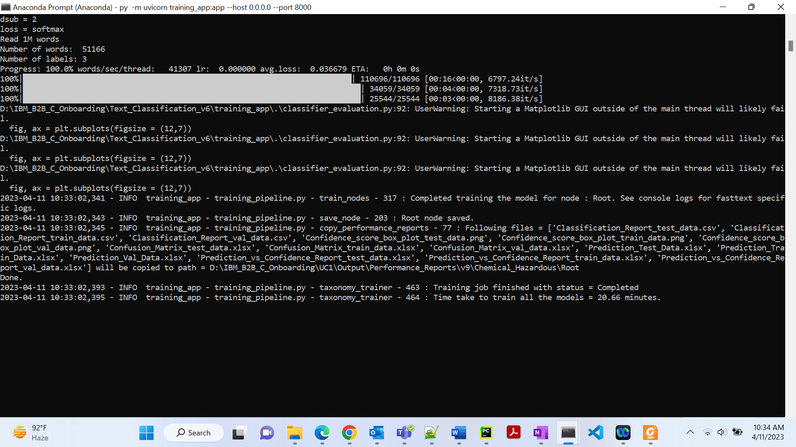

Flat classification, Total time taken to train all the models = **23 minutes**

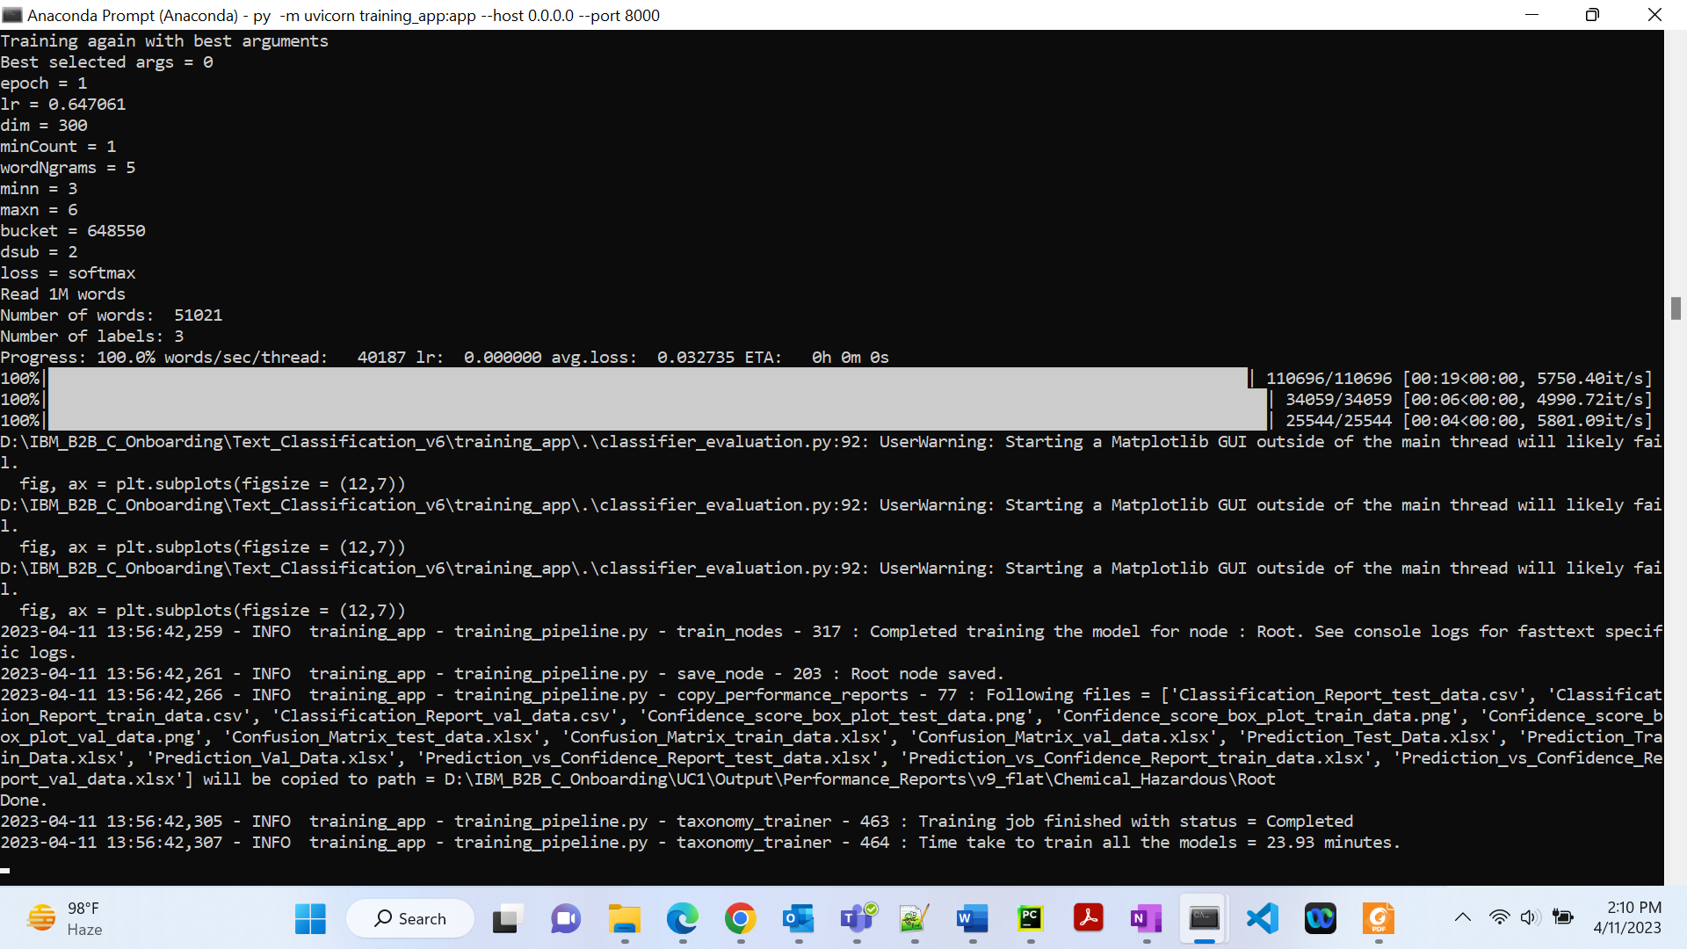

1. **Full dataset**

Here n_process:4, use_multiprocessing:True, flat_classification:true.

Time taken to train all the models = **18 minutes**

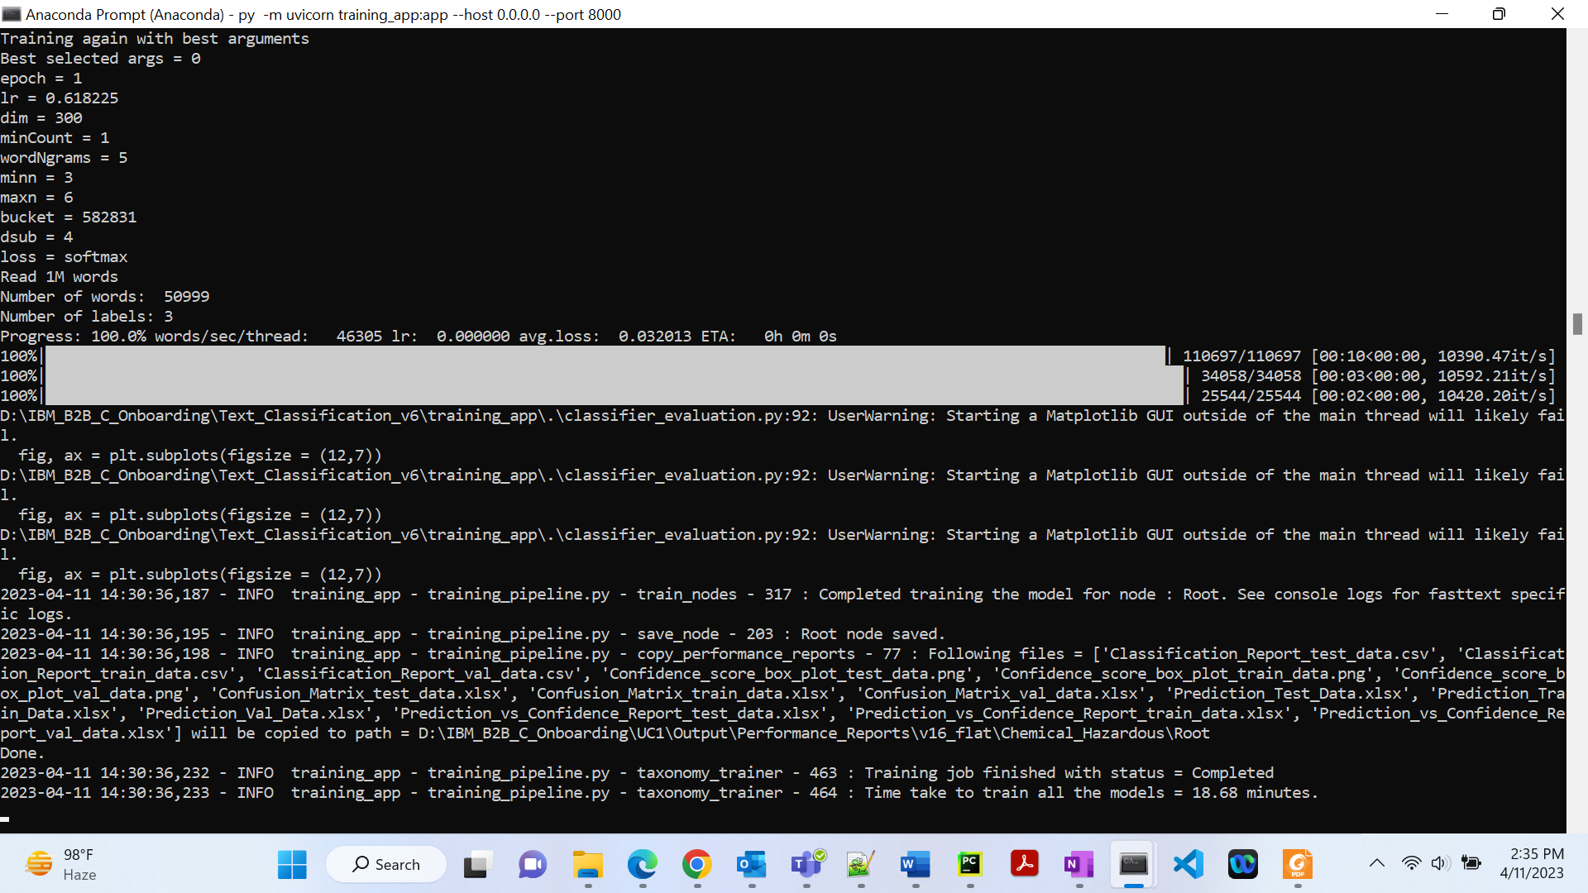

1. **Half dataset**

Here n_process:4, use_multiprocessing:True, flat_classification:true, autotune_duration: 180.

Time taken to train all the models = **12** **minutes**

